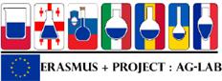

Georgian Delegation Visit in UniTE
Report
3-6 October, 2021 Teramo, Italy
Improving Laboratory Practice Skills for Agri-Food Specialists (Ag-Lab)
The representatives of Ivane Javakhishvili Tbilisi State University, Caucasus International University and State Laboratory of Agriculture participated in a workshop held on 3-6 October, 2021 at the University of Teramo, one of the European partners of the project, within the framework of the project “Improving the Laboratory Practice Skills of Agrarian and Food Specialists in Eastern Europe / Ag-Lab”.
On October 4, the Rector of University of Teramo met with the representatives of Georgian Delegation followed by study tour at Veterinary physiology and Microbiology area of UniTe. Prof. Nicola Bernabò presented research data and methodology of “Innovative approaches to reproductive biotechnology” and Dr. Giorgia Perpetuini introduced the presentation on “Selection of yeasts in wine production”. On October 5 and 6, the working group visited the wineries in the Abruzzo region, where they have visited Analytical chemistry area, where visitors got acquainted with on – going research lines, in particular, “Development of rapid low cost screening assays for food quality and safety control”, LC-MS and MALDI-TOF- TOF as useful tools in food analysis”. Q&A sessions took place after the presentations.
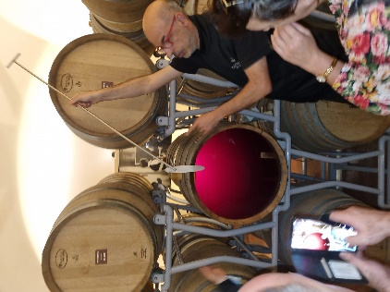 | 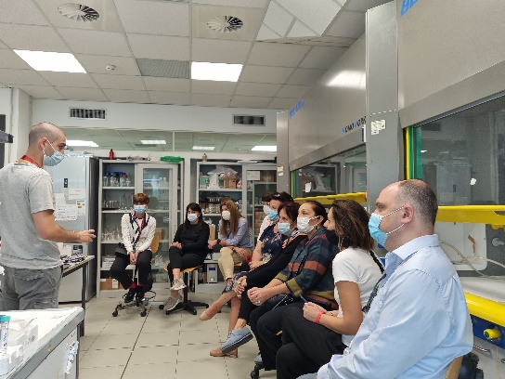
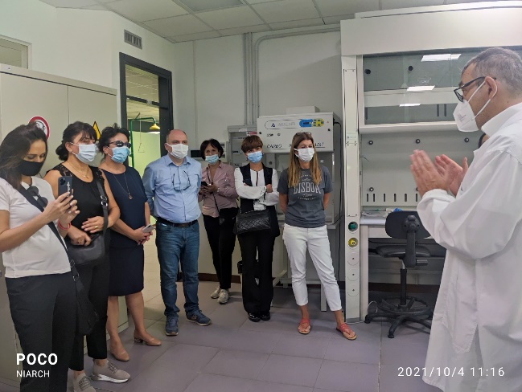 | 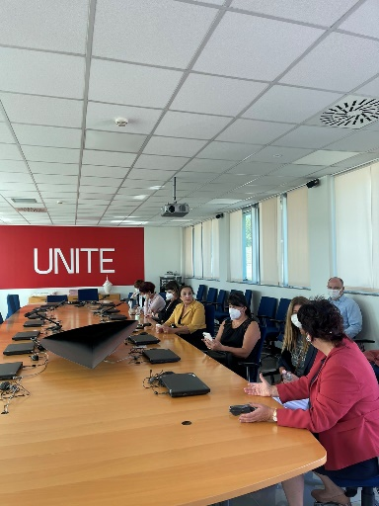

Activities Programme, UNITE
4-6 October, 2021

Day | Time table | Room | Activity
Monday 4th | 9.00-10.00 | Thesis room Polo  Spaventa | Welcome at University, visit of the labs of the faculty
 | 10.00-13.00 | Veterinary physiology  area | Prof. Nicola Bernabò “Innovative approaches to reproductive biotechnology”
 | 14.30-17.30 | Microbiology  area | Dr. Giorgia Perpetuini “Selection of yeasts in  wine production”
 | 19.30 | Dinner
Tuesday 5th | 8.30- 19.00 |  | Visit of Wineries Orsogna and Zaccagnini
Wednesday 6th | 9.00- 13.00 | thesis room and Analytical  chemistry area | Prof. Michele Del Carlo “Development of rapid low cost screening assays for food quality and safety control”
 | 14.30-  17.30 | thesis classroom and Analytical chemistry  area | Prof Sergi Manuel “ LC-MS and MALDI-TOF- TOF as useful tools in food analysis”

